Project Egg Hunt

PROJECT PLAN

THE VERSION HISTORY OF THE DOCUMENT

VERSION NUMBER | DATE | REASON FOR CHANGE | AUTHOR/ACCEPTOR
0.02 | 15.03.2018 | Added deliverables | Jaakko Lankila
0.01 | 15.03.2018 | First version | Jaakko Lankila

Contents

PROJECT PLAN 1
1. INTRODUCTION 3
1.1 The Aim of the Document 3
2. THE CONTENTS OF THE PROJECT 4
2.1 Background Information and Starting Points of the Project 4
2.2 Subject 4
3 ORGANIZING THE PROJECT 5
3.1 Supervising Group 5
3.2 Project group 5
4 DELIVERABLES 6

INTRODUCTION

The Aim of the Document

This document is aimed at the supervising group. The content of the document describes the background information, starting points and the target system of the project.

2. THE CONTENTS OF THE PROJECT

Background Information and Starting Points of the Project
The project is part of the web programming module. The project partners are first year Information Technology students of the Oulu University of Applied Sciences. The project partners have previous work experience, but not with each other.

Subject

The application can be used by a player and the admin. The player can start a play session. Before doing so, they must create a user, if they have not done so already. The system then identifies the player.
The admin can start an admin session, in which they can ban misbehaving players. The admin is also required to log in to the system.

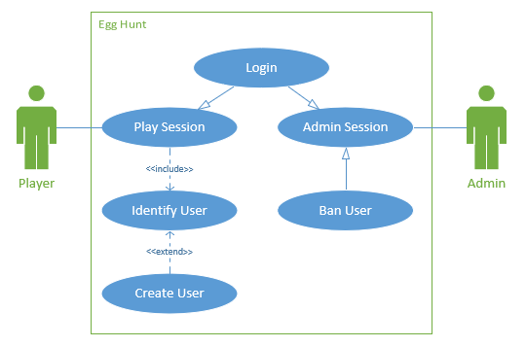
UML figure 1 Target system of the project

ORGANIZING THE PROJECT

Supervising Group
The supervising group of the project consists of the following persons.
Supervisors’ names and contact information will be filled in the table below.

NAME: Pekka Alaluukas
ROLE | Supervising group member
CONTACT INFORMATION | Organization: OAMK  E-mail address: pekka.alaluukas@oamk.fi  Phone: -

NAME: Kari Laitinen
ROLE | Supervising group member
CONTACT INFORMATION | Organization: OAMK  E-mail address: kari.laitinen@oamk.fi  Phone: -

Project group
The project group consists of the following persons.
NAME: Erik Maresia
ROLE | Front-end Developer
CONTACT INFORMATION | Organization: OAMK  E-mail address: t7maer00@students.oamk.fi  Phone: -

NAME: Florian Brandsma
ROLE | Back-end Developer
CONTACT INFORMATION | Organization: OAMK  E-mail address: t7brfl00@students.oamk.fi  Phone: -

NAME: Jaakko Lankila
ROLE | Front-end Developer
CONTACT INFORMATION | Organization: OAMK  E-mail address: t7laja02@students.oamk.fi  Phone: -

DELIVERABLES
The final result of the project includes the following:
- Source code
  - HTML
  - CSS
  - JavaScript (jQuery, p5.js)
  - PHP
- The project executable hosted on mysli
- Documentation
  - Project plan
  - Function plan
  - Test report
- Graphical assets
  - png

